**Title: Terrain Mapping at night using Drone**

**Team Name: Blue_Origin**

**Team Members:** *Promit Roy* | *Soumik Samanta* | *Subhodeep Santra* | *Akash Manna* | *Amit Bose*

**Introduction:**

The objective of our drone is to map the terrain at night time. It will help us to map the terrain of abandoned caves(specially), houses, devastated area. Drone mapping can solve that clarity issue. A highly detailed aerial map allows for insight into the property details without requiring a client to be there in person.  The drone may have obstacle avoidance sensors which will help it to avoid obstacles and will have onboard camera and lasers. Using classical method of terrain mapping (**Range Finder Technique**), we will measure the changes in elevation of the ground.

**Technology stack:**

* Drone Platform
* Pixhawk (flight controller)
* Lasers
* Camera
* Open-cv (python module)

**Working Principle:**

* We use **concept of similar triangle** for measuring the elevation of terrain with respect to a certain reference ground level.
* The formula behind our approach are as follows:

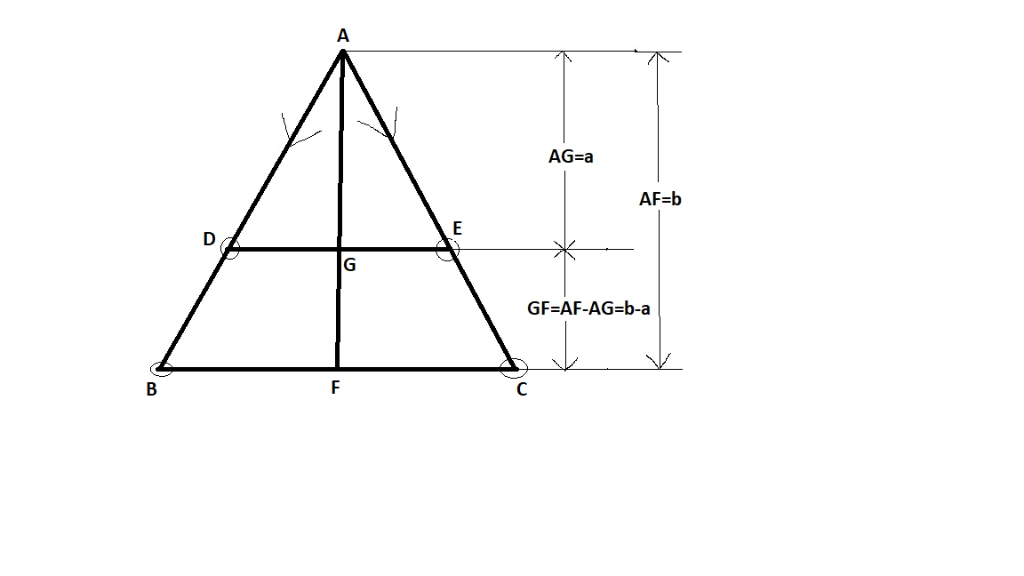

* Consider the above ABC, with the lasers (mounted on the drone) placed in the direction of side AB and AC (as shown above). B, C are the laser dots for **reference ground level** and D, E are the laser dots for **new level**.
* Using open-cv we will form contours around two red dots then find the centroid of those two contours say **centroid1= (x1, y1)** (for one laser dot) and **centroid2= (x2, y2)** (for second laser dot)
* So, distance between two centroids, **d = $\frac{\sqrt{{\left(x1-x2\right)}^{2}+{\left(y1-y2\right)}^{2}}}{1}$**  , that is value of DE and BC are obtained from open-cv.
* From above geometry we can see that ABC and ADE are similar triangles. By property of similar triangles:

$\frac{a}{b}=\frac{DE}{BC}$, here the value of DE, BC and b(height w.r.t. to reference ground level) is known.

The height of new level w.r.t. drone, **a=b $\frac{DE}{BC}$\*** ……(1)

* So the terrain height will be,

**h=AF – AG = b – a =b – b $\frac{DE}{BC}$\*** ….using(1)

**h=b*(1 - $\frac{DE}{BC}$)** …….. (*OUR RESULT*)

**Conclusion and Future Perspective:**

The approach/solution so far mentioned, uses classical image processing technique like **Range Finder Technique.** Later on, **stereo imaging** and **motion parallax** can be used to make the drone function autonomously, and thereby avoid obstacle in its path and hence will increase the efficiency of terrain mapping.